# Creating First Jenkins Job

CLICK ON **NEW ITEM** – <TYPE THE ITEM NAME> -- **FREESTYLE PROJECT** – CLICK ON OK

NOW CONFIGURATION :--

* DESCRIPTION – Give the description as per your requirement
* SOURCE CODE MANAGEMENT – either u want the code to be imported from Git
* BUILD TRIGGERS – how you want to run this.
* BUILD
  + - * COMMAND – here enter the command which you want to execute
      * ADD BUILD STEP – here generally we give WINDOWS BATCH COMMAND
      * POST BUILD ACTION –

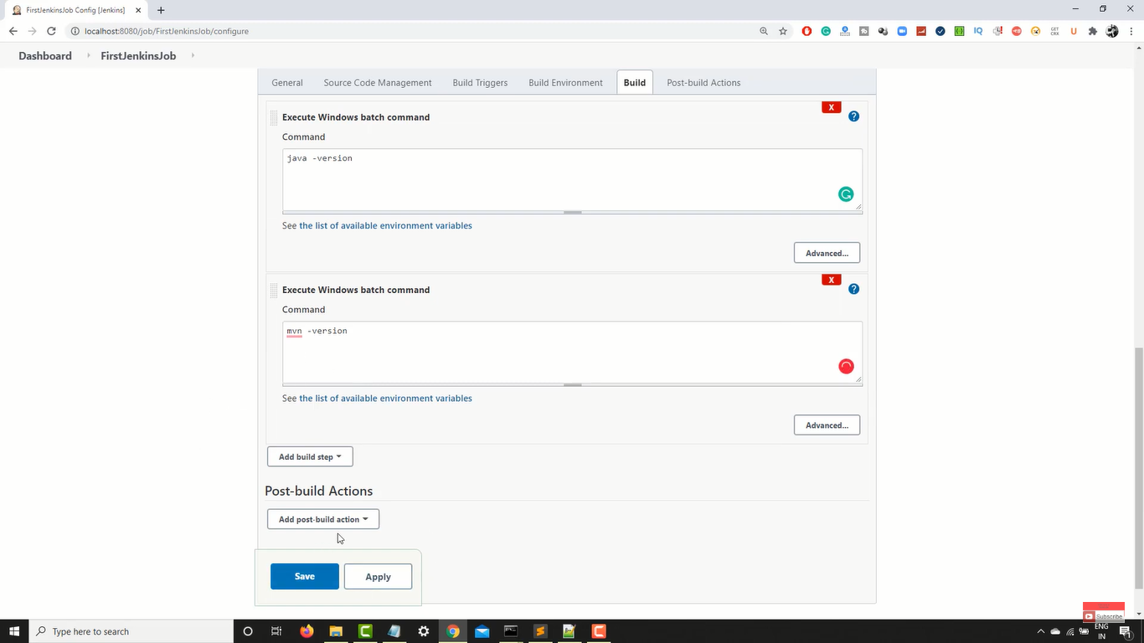

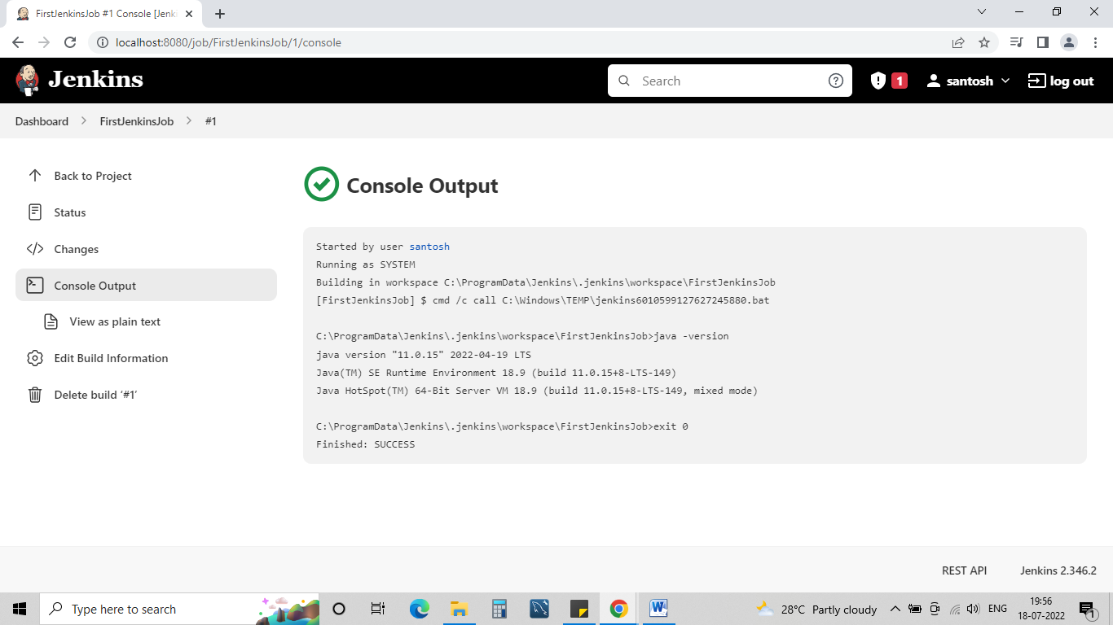

# Configure Email in Jenkins

Email is used for events like if a test case pass/test case fail/build success etc we can send email by default

2 WAYS :---

**FIRST :---** Click on MANAGE JENKINS -- CONFIGURE SYSTEM – E-mail notification

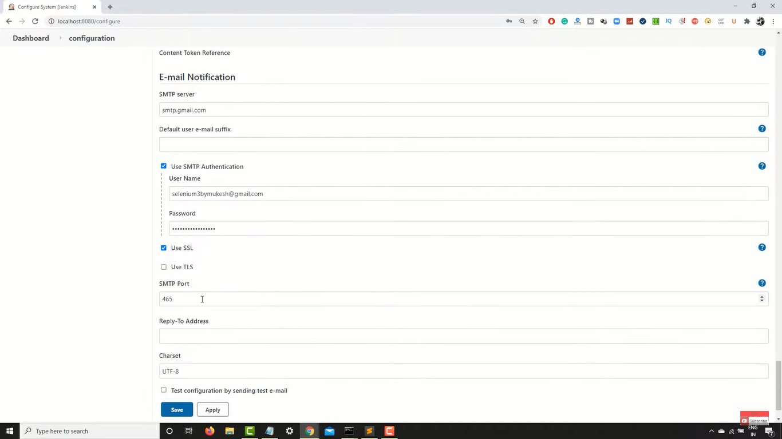

Under USE SMTP AUTHENTICATION – we need to give the SENDER mail id and passowrd

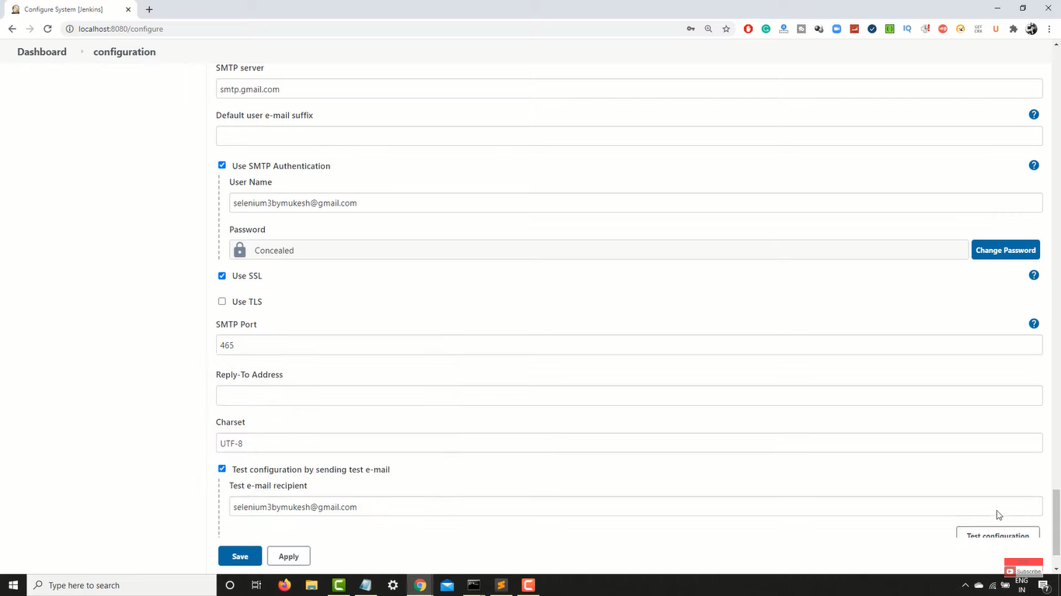

TEST EMAIL RECEPIENT – we need to give RECEIVER EMAIL ID

**SECOND :---** Click on MANAGE JENKINS -- CONFIGURE SYSTEM -- Extended E-mail Notification

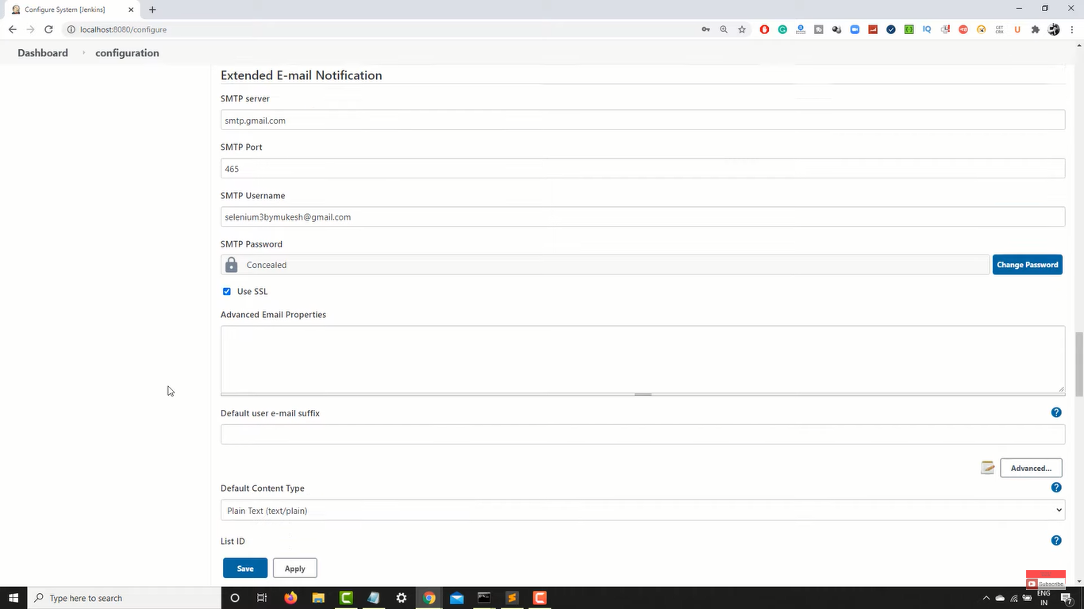

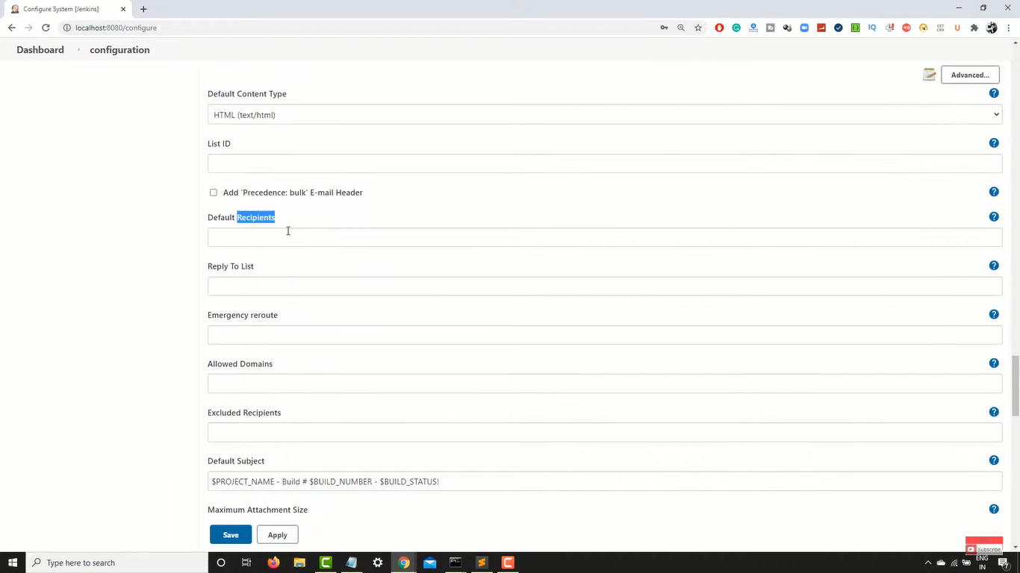

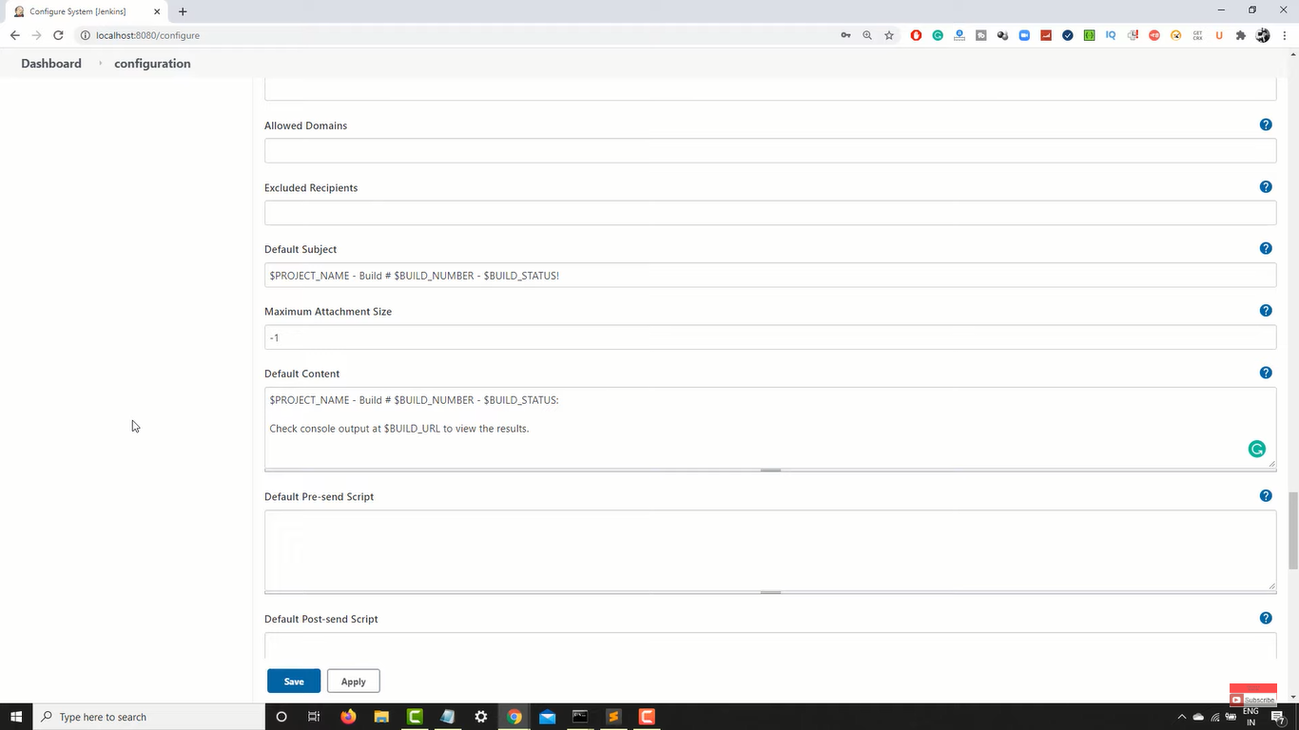

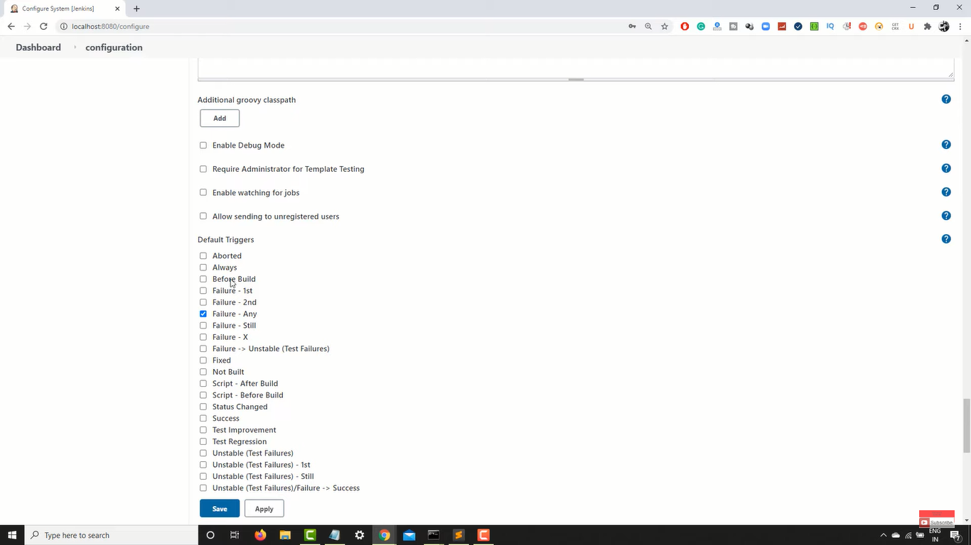

**NOW IN OUR JOB – UNDER THE POST BUILD ACTIONS**

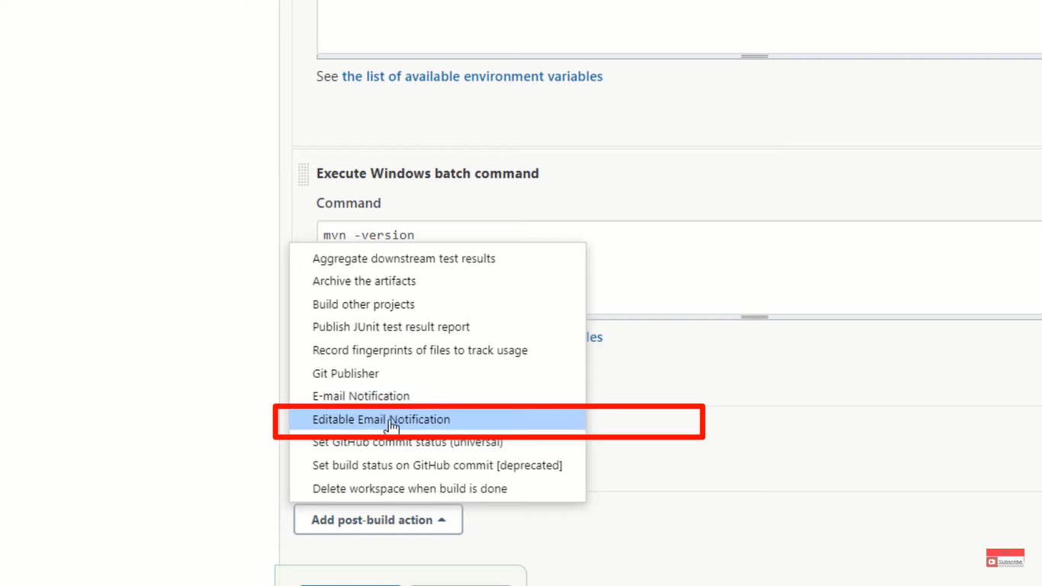

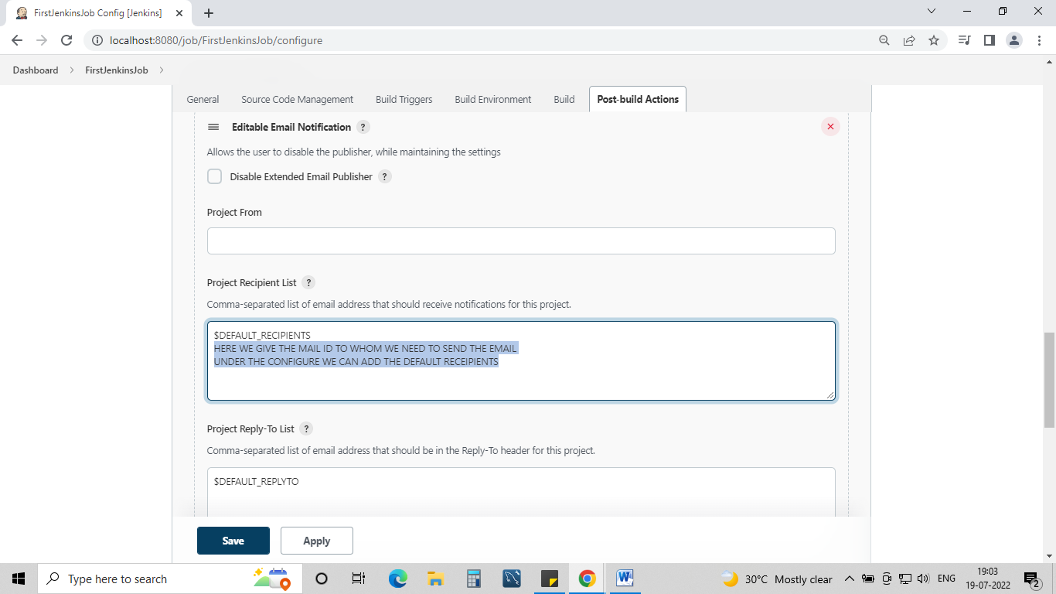

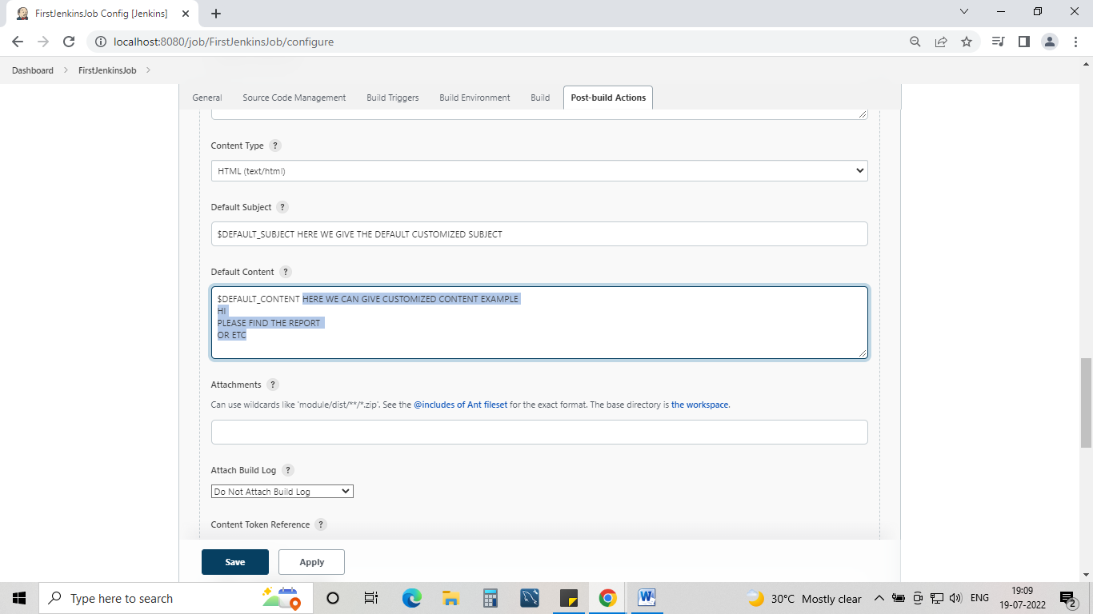

**AFTER THIS – CLICK ON – ADVANCED SETTINGS – where u can find more options**

https://wiki.jenkins.io/display/JENKINS/Building+a+software+project#Buildingasoftwareproject-belowJenkinsSetEnvironmentVariables

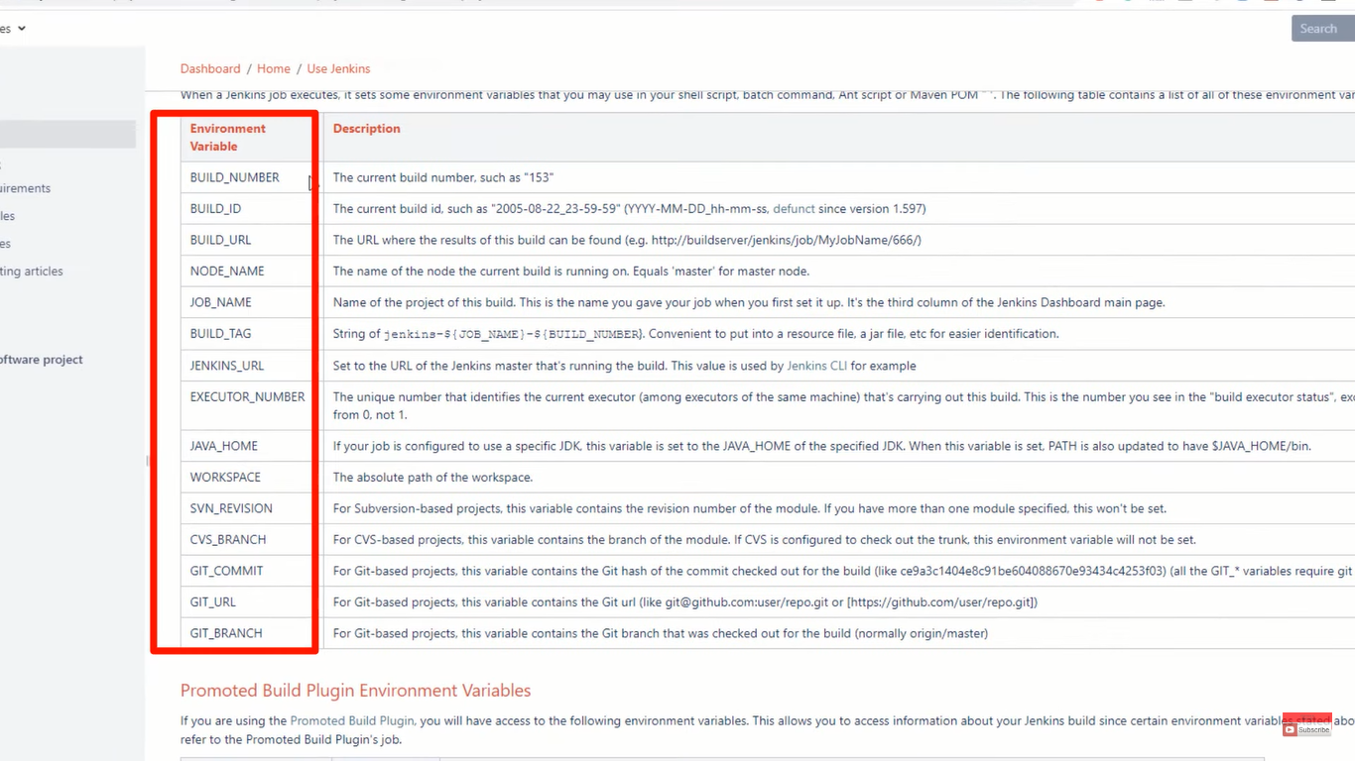

The above u can see the **Environment Variable** which we can use in the Email configuration.

**NOTE** :-- **$** is must before we use the Environment variables

# Manage Plugins in Jenkins

Click on – manage Jenkins – manage plugins –

# Build Maven Project In Jenkins

